Manual Order Process
- Login to the Admin Dashboard

- Select Manage Token Distribution
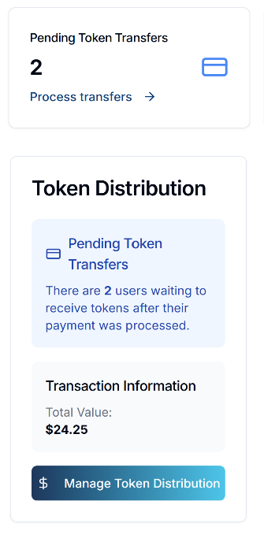
- Open the Main Order Log

- Double check to determine if all orders are up to date
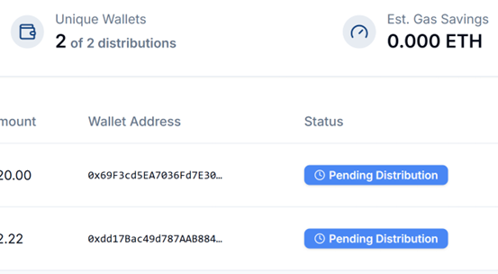
- Download and open the CSV file with the pending distribution
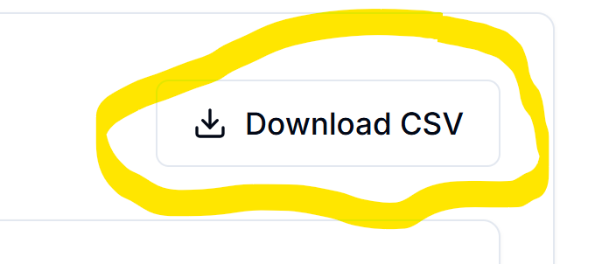

- Go to https://classic.multisender.app/ for Polygon orders



and https://solana.multisender.app/ for Solana orders



- Connect your wallet
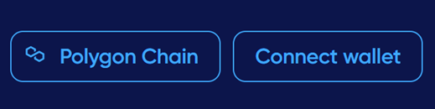

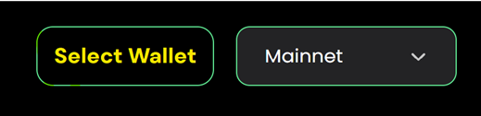

- Select the CSL token for the token address and “No” to the token being deflationary
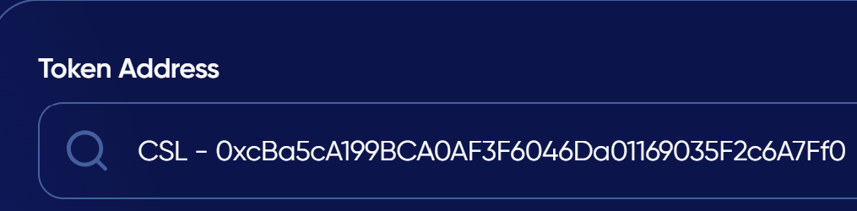

- Upload or copy and paste the pending distribution on the spreadsheet and press “Continue”
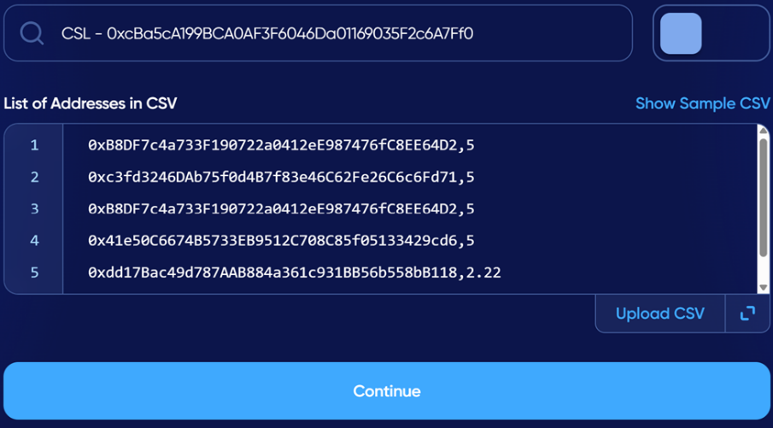

- Make sure the wallet addresses, and token amounts are separated by a comma

- Double check the addresses uploaded against the addresses in the pending distribution spreadsheet

- Check for errors and duplication before signing on the blockchain

- Take a screenshot before signing 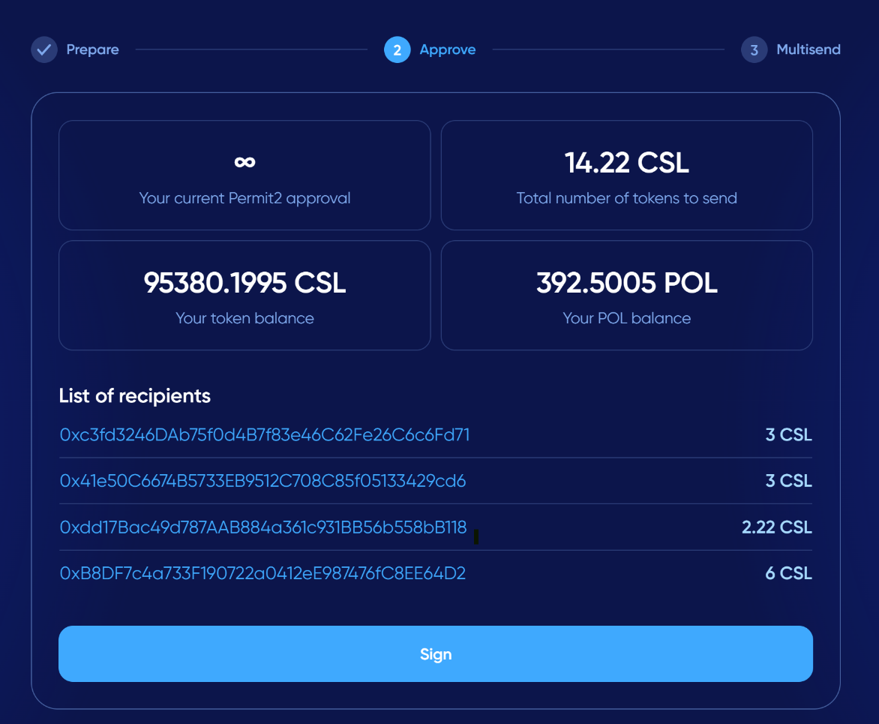

- Sign

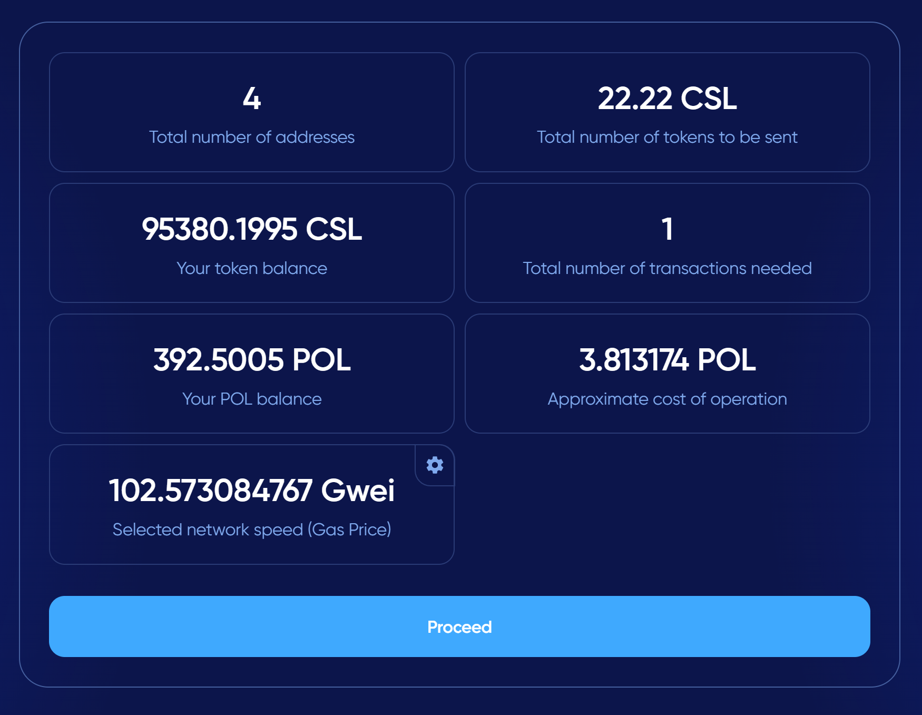

- Check the blockchain to ensure that the transaction is verified
  - Polygonscan for Polygon: https://polygonscan.com/
  - Solscan for Solana: https://solscan.io/

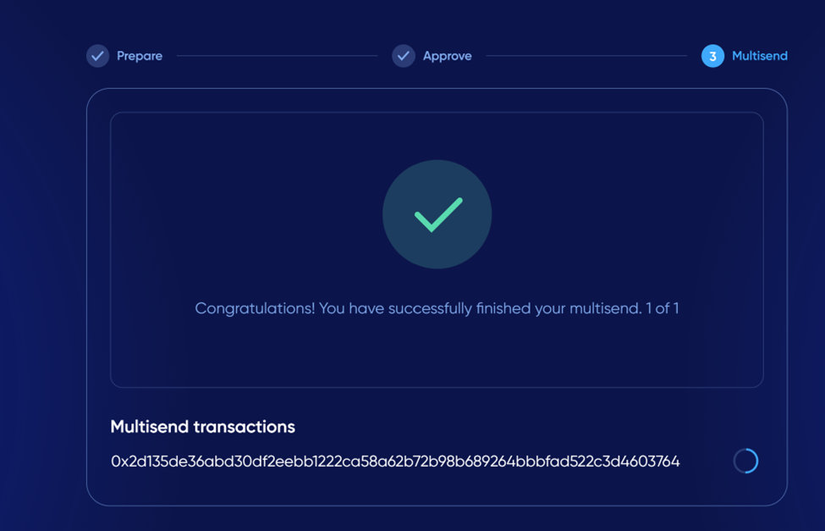
- Add the blockchain transaction ID and mark the order as “Sent” in the Admin Portal

- Update the Main Order Log

- Mark the orders as sent in the Admin Portal

